**Name**

**Lab#8: Advanced Cryptography**

**Step-1:** First we opened the website

Then we click first website under Recent best

**Step3: then we selected the first ip address**

**Step-4:**

We note the overall rating is A+. for certificate it has 100 points. For protocol support it has 100. Key exchange and cipher strength holds above 80 points.

**Step-5:**

We see the reason why the website does not received A because site only work in browsers that supportrs SNI.

**Step 6:**

After scrolling down we note the authentication information. It has digital certificate RSA using SHA256. It shows common names and alternative names. Serial number is also mentioned. Validity is mentioned from Tue 7 jun to Mon 5 Sep as well as other information you can see below in the image.

**Step 7:**

When we scroll down it shows configuration. It supports TLS 1.2.TLS 1.1 could also not be supported because NIST currently suggests everyone upgrade to at least version TLS 1.2 so it depends on which security protocols that want to establish going forward. I would say that TLS 1.0 would be the next to not be supported . Because it has been found to be susceptible to the BEAST attack. As TLS is continuation of SSL.It has been discovered in the deprecated SSl and Tls protocls. For this reason we should disable SSlv2, SSlv3, TLS 1.0 and TLS 1.1. leaving only Tls 1.2 and Tls 1.3 enabled.

**Step 8**

As we know security protocols use cipher suites such as TLS and its deprecated predecessors SSL. They are a set of algorithms used to secure network. They should be placed in sequence to ensure security. There order is as follows Risk, Probability and impact. They should be listed as the lower bit suites first then the higher bit.

**Step 9:**

Now we test with browser and operating system that we use.

**Step 10:**

Now we click on worst case scenario after clicking scanning back

**Step 11:**

Now we review summary authentication and configuration, cipher suites and handshake simulation.

**Step 12:**

As by reviewing according to my opinion top 5 vulnerabilities are

* Server Vulnerability to attack,
* certificate for a trusted cite,
* a strong key exchange,
* Protocol support,
* Cipher strength

**Step 13:**

Now I generate the report for the organization where I work. As you can see below we receive A score

**Step 14:**

 I completely agree with this site's score because, even though some cipher suites are week, which makes the cipher strength be lower than 100, the site has a perfect protocol control, a good key exchange and all the handshake simulations

**Step 15:**

Now we review other factors

Summary

Authentication

Configuration and cipher

Handshake

**Step 15:**

* Protocols TLS 1.1 and TLS 1.0 vulnerable to beast attack.
* No handshake compatibility
* Cipher strength
* Certificate for trusted cite
* Strong key exchange.

**Step 16:**

Now we test our own brower.

**Step 17:**

**Step 18:**

We closed the browse now

**Step 19:**

Now we opened internet explorer to check vulnerabilities

**Step 20:**

We see that there are too many vulnerabilities in Internet Explorer also it supports depreciated protocols that’s why google chrome is better then IE.

**Step 21:**

All browsers closed.

**Q1:**

A1: I observed that a good website needs to use new protocols and stronger cipher suites to tackle vulnerabilities. Also cipher suite should be placed according to risk, probability and impact.

**Exercise 2:**

We use command given to show certificates

Certificate authority approved is show

Intermediate Certificate authorities

Revoking certificates

It shows when was certificate revoked and also its serial number value.

Untrusted Certificates

This shows certificates that are no longer trusted and are

Q2:

**Digital certificates:**

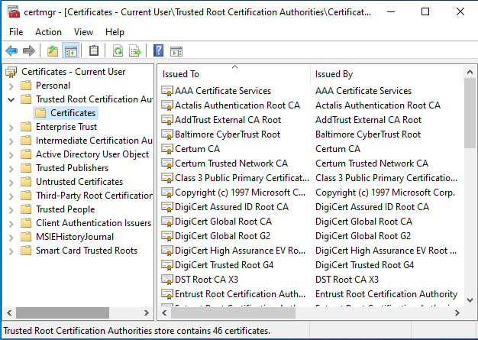

Digital certificates can be described as electronic files that are used to identify people and resources over network such as the internet. They enable secure,confidential communication between two parties using encryption. They are issued by CA. They have advantage over ink signatures. As they are given to data types based on their categories.